# Pronto

## Agile Architects

#### Group Members:

* Shashin Gounden
* Bandisa Masilela
* Andile Ngwenya
* Tyrone Sutherland-Macleod
* Jonel Albuquerque

# Table of Contents

[Cover Page]

Table of Contents

1.1. Introduction

A. Vision and Objectives

B. Business Need

C. Project Scope

Defining deliverables

I. User registration and authentication

II. Timetable generation:

III. Institution pages:

IV. Processing lecture schedules:

V. Notifications:

VI. Mobile support

VII. Web support

VIII. Reminders

IX. Geo-location services

X. Extracting and transforming the lecture schedule

1.2. User Stories/Characteristics

A. Students

B. Lecturers

C. Institution

D. Any user

1.3. Functional Requirements

Requirement 1: User Registration and Authentication

Requirement 2: Timetable Generation

Requirement 3: File Upload/Retrieval

Requirement 4: Notifications

Requirement 6: Geo-Location Services (Optional “wow factor” for later)

2.2. Diagrams

A. Use case Diagrams

1. User Registration and Authentication

2. Timetable Generation

3. File Upload/Retrieval

4. Notifications

5. Notifications

6. Geolocation Services

B. Class Diagram

C. High Level Architecture

# 

# Introduction

### Vision and Objectives

Pronto is a multi-purpose application that will be used by universities, lecturers, and students. Students will be able to create, edit and view custom timetables. Lecturers will be able to schedule reminders for important events like exams and project due dates, as well as notify them of assignment extensions. Institutions will be able to upload their university lecture schedules and campus maps. This application aims to help students organise their schedules and also bring together the features of reminders, navigation, and lecture timetables into a single application.

### Business Need

Currently, there is no single consolidated application that allows students from any higher education institution to create a timetable based on the modules they are taking. Features for different parts of the application exist in isolation, and we intend to design a system that brings these features into a single place for any student of any university.

### Project Scope

#### Defining deliverables

The scope of the project involves developing a proof of concept web/mobile application using Amazon Web Services ([AWS](https://aws.amazon.com/)) as the underlying infrastructure. The core functionalities and features that we need to develop include:

##### User registration and authentication

* + Users, including students, institutions, and lecturers, will be able to create accounts and authenticate themselves to access the application.
  + Users will be assigned different roles that will enable them to use the system differently based on their user group.

##### Timetable generation:

* + Students will be able to create schedules based on their module choices, and also view assignment deadlines, upcoming tests and examination schedules, and other important events.
  + They can also set reminders and define how they would like to receive notifications for upcoming tasks. (E-mail, SMS, or push notifications)

##### Institution pages:

* + Institutions will have the ability to create and maintain their own pages within the application.
  + They can load and update student schedules, campus maps, assignment deadlines, test and examination schedules, and other relevant information. Students will be able to access these documents and relevant information by visiting their page.

##### Processing lecture schedules:

The application will allow institutions to upload their lecture schedules in the form of a .csv or .xls file, which will then be processed and stored so that a student can search for a module and have its information generated for their timetable.

##### Notifications:

The application will allow for three notification types that the user can select :

* + Push
  + Sms
  + Email

Students can set which type of notification they would like to receive from these options.

##### Mobile support

The application should be accessible and responsive on mobile devices, allowing students to conveniently access their tasks and receive notifications on the go.

##### Web support

Users that are universities or lecturers will use an application with a web view to create their accounts, manage their pages, and set reminders respectively.

##### Reminders

The application will provide reminders to students for upcoming deadlines, events, or any updates from their institutions. These will be presented to the user via the notifications subsystem

Additionally, the optional functionalities and features that we would like to develop include:

##### Geo-location services

Students should be able to use a map service within the application that will give them directions to a lecture hall from their current location. This service will use a walking distance calculator to work out the time required to navigate between the lecture venues.

##### Extracting and transforming the lecture schedule

When an institution uploads its lecture schedule, we would like to take the provided format and transform it into a standard format for storage and consistency purposes. With this, inconsistencies with naming formats can be addressed.

As it stands, we plan to be finished with the core deliverables by the 24th of July 2023. Thereafter, development on the optional deliverables will begin and finish by the 20th of September 2023.

**Identifying constraints**

* All modules and tools used outside of AWS services should be open source and documented.
* All data that we store needs to be stored and used securely. Privacy of users should be taken into account with the design, making sure to consider POP, GDPR, PII, etc.

*[insert milestones here once decided]

# User Stories/Characteristics

### Students

1. As a student, I want to be able to create a custom timetable based on the lectures I have, so that I can stay organised and have an easy way to make a timetable.
2. As a student, I want to be able to view assignment deadlines, upcoming tests and examination schedules, and other important events, so that I can plan my schedule accordingly.
3. As a student, I would like to define how I would like to receive reminders for my upcoming tasks so that I can receive notifications in a way that works best for me.
4. As a student, I want to be able to receive notifications about upcoming deadlines or events, so that I never miss important information.
5. As a student, I want to be able to access my institution's page, so that I can easily find relevant information and documents.
6. As a student, I want to be able to use a map service within the application that will give me directions to a lecture hall from my current location, so that I can easily navigate around campus.

### Lecturers

1. As a lecturer, I want to be able to schedule reminders for important events like exams and assignment due dates so that my students are aware of upcoming deadlines.
2. As a lecturer, I want to be able to change assignment deadlines or test dates as the need arises, and for my students to be notified of these changes.
3. As a lecturer, I want to be able to send out important announcements regarding tests or assignments to my students so that they can be notified immediately of important changes.

### Institution

* 1. As an institution, I want to be able to upload files like our university lecture schedules, campus maps, and other relevant information so that students can easily access it.
  2. As an institution, I want to be able to update lecture schedules, and other relevant information about the institution, so that students always have access to the most up-to-date information.

### Any user

* 1. As a user, I want all of my data stored safely and for the privacy of my data to be taken into account so that my personal information is protected

# Functional Requirements

### **Requirement 1**: User Registration and Authentication

**Sub-Requirement 1.1**:

Pronto will allow users to create a new account by providing their name, email, and password. Accounts will be divided into student accounts and lecturer accounts.

**Sub-Requirement 1.2**:

Pronto shall provide the capability for users to log in to the application using their email and password. Users can log in as either students or lecturers with different privileges.

**Sub-Requirement 1.3**:

Pronto will allow students to pick which university they attend after signing up to get content related to their university.

**Sub-Requirement 1.4**:

Pronto will allow all users to edit their account details, like their name, phone number, and password.

### **Requirement 2:** Timetable Generation

**Sub-Requirement 2.1:**

Pronto shall provide a search capability for modules to students.

**Sub-Requirement 2.2**:

Pronto will allow students to delete modules from their subject list.

**Sub-Requirement 2.3**:

Pronto will allow students to add modules to their subject list.

**Sub-Requirement 2.4**:

Pronto will allow students to edit their timetable by selecting activities for each module.

### **Requirement 3**: File Upload/Retrieval

**Sub-Requirement 3.1**:

Institutions can update student schedules, campus maps, assignment deadlines, test and examination schedules, and other relevant information.

**Sub-Requirement 3.2**:

Students can access these documents and relevant information by visiting their institution's page.

**Sub-Requirement 3.3**:

Institutions can upload their lecture schedules in the form of a .csv or .xls file.

### **Requirement 4**: Notifications

**Sub-Requirement 4.1**:

The application will allow students to select from three notification types (push, SMS, email).

**Sub-Requirement 4.2**:

The students will be able to receive reminders for upcoming deadlines, events, or any updates from their lecturers.

**Requirement 5:** Reminders

**Sub-Requirement 5.1**:

Lecturers can set reminders for due dates, test dates and any important events that will be sent to students.

### **Requirement 6:** Geo-Location Services (Optional “wow factor” for later)

**Sub-Requirement 6.1**:

Students can use a map service within the application that will give them directions to a lecture hall from their current location.

**Sub-Requirement 6.2**:

Students should be able to see the time required to navigate between the lecture venues.

**Sub-Requirement 6.3**: Pronto will allow lecturers to interactively pin locations of lecture venues.

# Diagrams

## Use case Diagrams

### 1. User Registration and Authentication

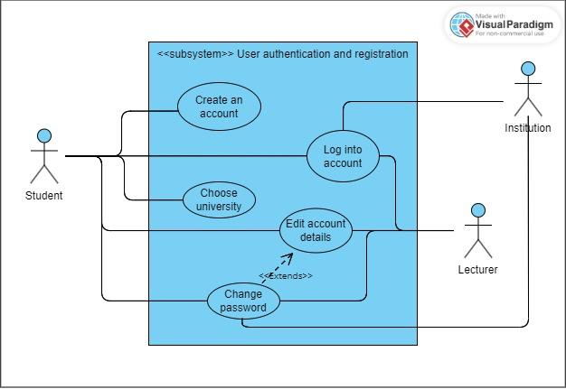

### 

2.Timetable Generation

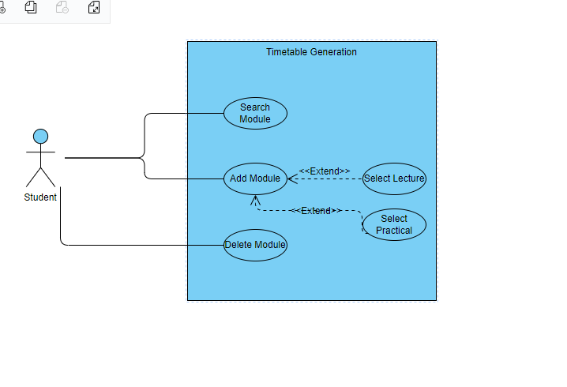

### 3. File Upload/Retrieval

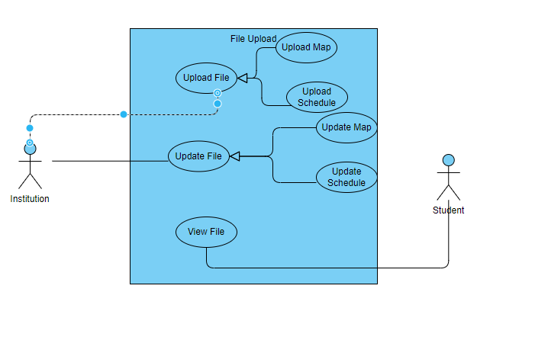

### 4. Notifications

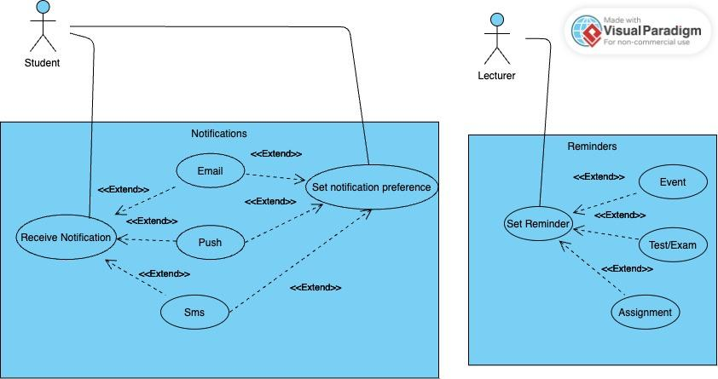

### 5. Reminders

### 6. Geolocation Services

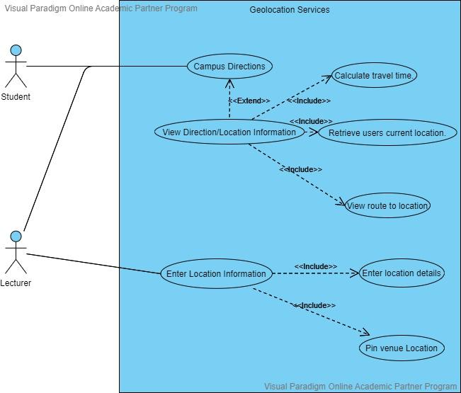

## Class Diagram

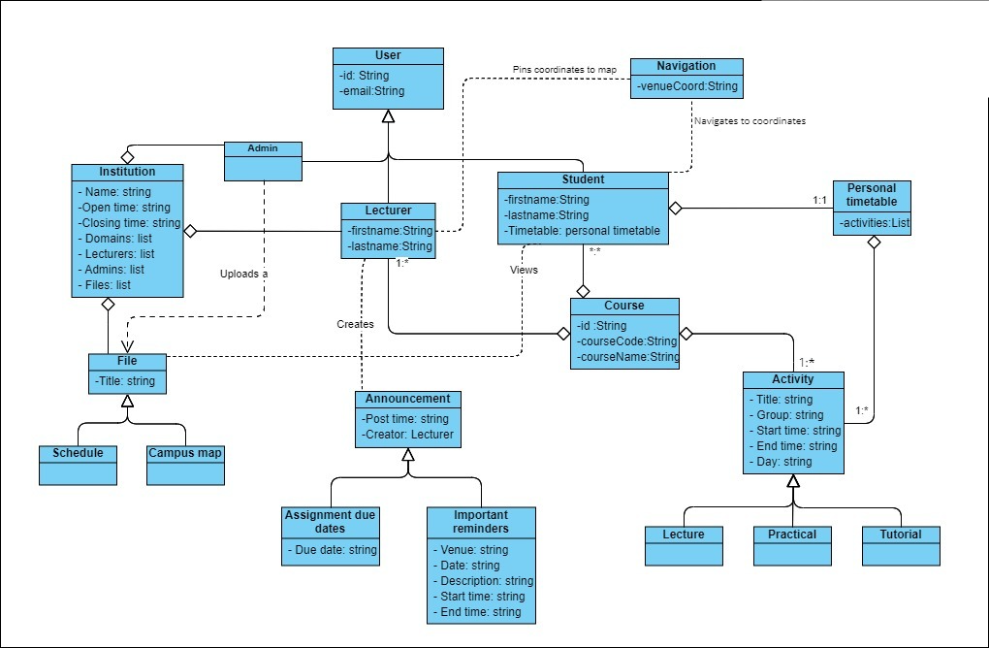

## High Level Architecture